🛡️ What Is Azure Policy?
Azure Policy is a governance tool that helps enforce organizational standards and assess compliance across Azure resources. It ensures that resources are created and maintained according to defined rules, such as location restrictions, tagging requirements, or security configurations.
🔧 Core Components
- Policy Definition: JSON-based rules that describe what is allowed or denied.
- Policy Assignment: Applying a policy to a scope (management group, subscription, resource group, or resource).
- Initiative Definition: A collection of policy definitions grouped to achieve a broader goal (e.g., regulatory compliance).
- Parameters: Dynamic values used in definitions to make them reusable.

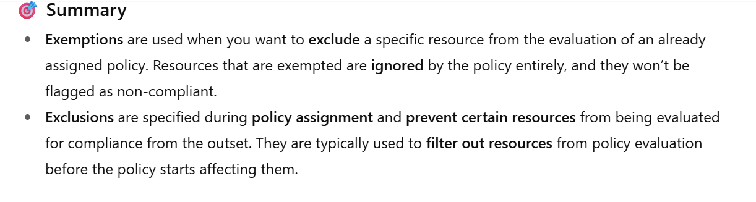
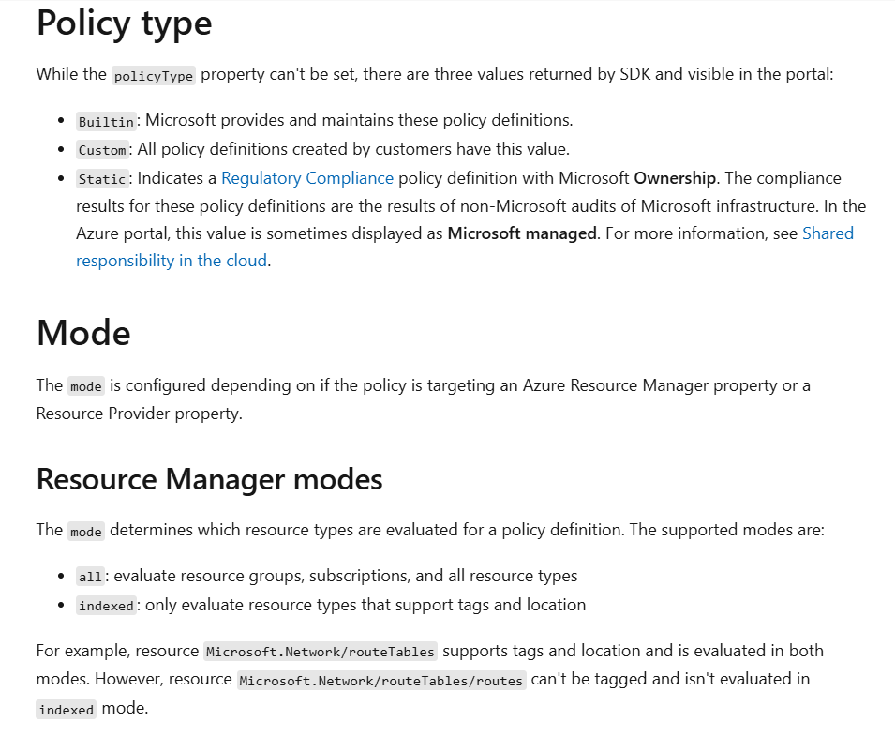

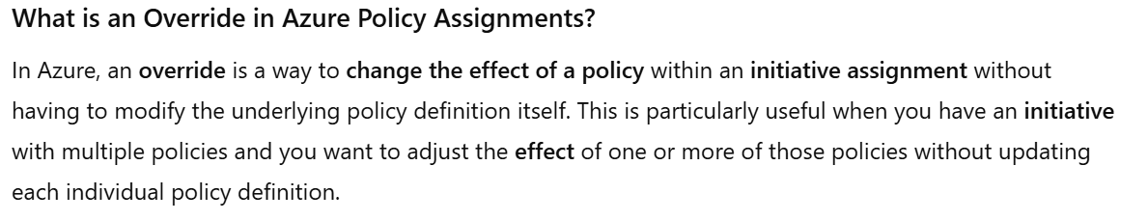

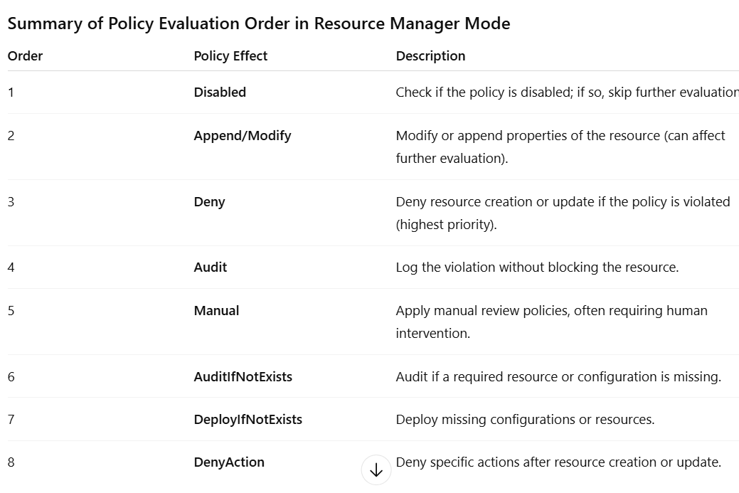
- 📊 Built-in Definitions and Initiatives
Item | Count (Approximate)
Built-in Policy Definitions | Over 400
Built-in Initiatives | Over 140
- You can explore them on Microsoft's official Azure Policy samples page.
- Limits Per Scope:
Object Type | Limit
Policy definitions per scope | 500
Initiative definitions per scope | 200
Initiative definitions per tenant | 2,500
Policy or initiative assignments per scope | 200
Exemptions per scope | 1,000
Max policies in an initiative | 1,000
Max parameters in initiative | 400
Max exclusions in assignment | 400

🔄 Azure Policy Flow
- Define: Create a policy or initiative using JSON.
- Assign: Apply it to a scope (e.g., subscription).
- Evaluate: Azure checks compliance during resource creation/update and every 24 hours.
- Enforce: Based on the effect, Azure may deny, audit, or remediate.
- Remediate: Optionally fix non-compliant resources using remediation tasks.

🧩 Types of Azure Policies
- Built-in Policies: Provided by Microsoft for common scenarios.
- Custom Policies: Created by users to meet specific needs.
- Initiatives: Grouped policies for broader compliance goals.

⚙️ Effects in Azure Policy
Effects define what happens when a resource violates a policy. There are 12+ effects, including:
Effect | Description
Deny | Blocks non-compliant resource creation/update.
Audit | Logs non-compliance without blocking.
Append | Adds properties to a resource.
Modify | Changes resource properties to make them compliant.
DeployIfNotExists | Deploys a related resource if missing.
AuditIfNotExists | Audits based on child or extension resource.
Disabled | Turns off the policy for testing.
Manual | Requires manual review.
DenyAction | Blocks specific actions.

Available Modes:
- Audit
- ApplyAndMonitor
- ApplyAndAutoCorrect

🧠 Guest OS Level Azure Policy
Guest Configuration Policies extend Azure Policy to inside the VM (Guest OS). They audit or configure OS settings like password policies, registry keys, or installed software.
🔍 Differences from Normal Policies
Feature | Guest Configuration | Normal Azure Policy
Scope | Inside VM OS | Azure Resource Manager
Agent Required | Yes (Guest Config Agent) | No
Identity Required | Yes (Managed Identity) | No
Use Case | OS hardening, compliance | Resource governance

🧾 What Is Guest Assignment?
A Guest Assignment is the link between a VM and a Guest Configuration Policy. It defines what configuration should be applied or audited inside the VM.
- Created automatically when a Guest Configuration policy is assigned.
- Managed via Microsoft.GuestConfiguration/guestConfigurationAssignments.
- Evaluated every 15 minutes for compliance.

✅ BIG PICTURE FLOW: From DSC Script to Azure Policy
Here’s the complete flow in plain steps:

🔹 1. You write a DSC Script
Example (Configure-EventLog.ps1):
Configuration AuditOtherLogonEvents
{
Node "localhost" {
Registry AuditOtherLogonEventsSetting {
Key = "HKLM\\System\\CurrentControlSet\\Services\\Audit\\AuditEvents"
ValueName = "OtherLogonEvents"
ValueData = "1"
Ensure = "Present"
ValueType = "Dword"
}
}
}

🔹 2. You compile DSC script to MOF file
.\Configure-EventLog.ps1
AuditOtherLogonEvents
- This generates:
.\AuditOtherLogonEvents\localhost.mof

🔹 3. Package MOF into Guest Configuration ZIP
You now use:
New-GuestConfigurationPackage `
-Name "AuditOtherLogonEvents" `
-Configuration .\AuditOtherLogonEvents\localhost.mof `
-Type Audit `
-Force
🔍 What this does:
- Wraps the MOF into a ZIP file compatible with Azure Guest Configuration
- Output:
.\AuditOtherLogonEvents.zip
✅ This ZIP is now your guest configuration package

🔹 4. Upload ZIP to Storage Account
Set-AzStorageBlobContent `
-Container $containerName `
-File .\AuditOtherLogonEvents.zip `
-Context $context
Then generate a SAS Token:
$contentUri = New-AzStorageBlobSASToken -FullUri ...
✅ This URI is required by Azure to read your GC package during policy evaluation.

🔹 5. Create the Azure Policy Definition
Now you run:
New-GuestConfigurationPolicy `
-ContentUri $contentUri `
-DisplayName "AuditOtherLogonEvents" `
-Description "Audit Other Logon Events on Windows VMs" `
-Path '.\policies' `
-Platform 'Windows' `
-PolicyId (New-Guid) `
-PolicyVersion '1.0.0'
🔍 What this command does:
- Reads your MOF/ZIP from blob storage (via the SAS URI)
- Automatically generates:
  - An Azure Policy Definition (with either AuditIfNotExists or DeployIfNotExists)
  - A JSON policy rule file (in the folder you specified via -Path)
- Saves the generated policy rule JSON file to:
.\policies\AuditOtherLogonEvents_AuditIfNotExists.json
✅ Now you have a valid Azure Policy that you can assign to subscriptions or resource groups.

Recap: Key Commands You Asked About
Command | What It Does
New-GuestConfigurationPackage | Packages your MOF into a .zip file that Azure Guest Configuration can understand
New-GuestConfigurationPolicy | Creates the Azure Policy Definition (with effect like AuditIfNotExists), using the .zip hosted in storage
Output | Saves the JSON policy rule locally and registers the policy definition in Azure

🧠 Frequently Confused Points – Let Me Clarify
❓ Q: Where does the JSON come from?
➡️ It's auto-generated by New-GuestConfigurationPolicy and saved in the path you specify (-Path).
❓ Q: Do I need to write JSON manually?
➡️ No. The policy rule JSON is auto-created based on the guest config package.
❓ Q: Do I need to use New-AzPolicyDefinition after New-GuestConfigurationPolicy?
➡️ No, New-GuestConfigurationPolicy already creates the policy definition. Use New-AzPolicyDefinition only if you want to register a JSON manually.

✅ Summary Flow
# 1. Create DSC config
Write-DSC.ps1 → AuditOtherLogonEvents.ps1

# 2. Compile DSC to MOF
AuditOtherLogonEvents.ps1 → localhost.mof

# 3. Package as Guest Config ZIP
New-GuestConfigurationPackage → AuditOtherLogonEvents.zip

# 4. Upload to storage
Set-AzStorageBlobContent + New-AzStorageBlobSASToken

# 5. Create Guest Config Policy
New-GuestConfigurationPolicy (uses SAS URI of ZIP)

# 6. JSON policy file is auto-created
./policies/AuditOtherLogonEvents_AuditIfNotExists.json

# 7. Policy is registered in Azure
Azure Portal → Policy → Definitions → AuditOtherLogonEvents

Would you like me to:
- Show you a real example of the generated JSON policy file?
- Help build and test this step-by-step using a sample DSC?
Let me know, and we can walk it together.

🔧 New-GuestConfigurationPackage – Syntax & Example
🔹 Purpose:
Packages your DSC MOF file into a .zip file that Azure Guest Configuration understands.

✅ Syntax:
New-GuestConfigurationPackage `
-Name <String> `
-Configuration <String | FileInfo> `
-Type <Audit | ApplyAndMonitor | ApplyAndAutoCorrect> `
[-Force] `
[-OutputFolder <String>] `
[-Platform <Windows | Linux>]

📌 Parameters:
Parameter | Required | Description
-Name | ✅ Yes | Name of the configuration (used as ZIP name)
-Configuration | ✅ Yes | Path to the MOF file (e.g. .\MyPolicy\localhost.mof)
-Type | ✅ Yes | Configuration mode: Audit, ApplyAndMonitor, or ApplyAndAutoCorrect
-OutputFolder | ❌ No | Where to save the .zip (default is current folder)
-Platform | ❌ No | OS type: Windows or Linux
-Force | ❌ No | Overwrites existing file without prompt

🧪 Example:
New-GuestConfigurationPackage `
-Name "AuditPasswordPolicy" `
-Configuration ".\AuditPasswordPolicy\localhost.mof" `
-Type ApplyAndAutoCorrect `
-OutputFolder ".\output" `
-Platform Windows `
-Force
This creates:
.\output\AuditPasswordPolicy.zip

🏗️ New-GuestConfigurationPolicy – Syntax & Example
🔹 Purpose:
Creates an Azure Policy definition that uses your Guest Configuration package hosted in a storage account (via SAS URL).

✅ Syntax:
New-GuestConfigurationPolicy `
-ContentUri <Uri> `
-DisplayName <String> `
-Description <String> `
-Path <String> `
-Platform <Windows | Linux> `
-PolicyId <Guid> `
-PolicyVersion <String> `
[-Verbose]

📌 Parameters:
Parameter | Required | Description
-ContentUri | ✅ Yes | SAS URL to the .zip file in Azure Storage
-DisplayName | ✅ Yes | Name shown in Azure Policy UI
-Description | ✅ Yes | Description of the policy
-Path | ✅ Yes | Output folder to save policy JSON file
-Platform | ✅ Yes | Windows or Linux
-PolicyId | ✅ Yes | A new GUID (unique ID for the policy)
-PolicyVersion | ✅ Yes | Your versioning (e.g. 1.0.0)

🧪 Example:
New-GuestConfigurationPolicy `
-ContentUri "https://<storageaccount>.blob.core.windows.net/<container>/AuditPasswordPolicy.zip?<SAS>" `
-DisplayName "Enforce Password Policy in Windows VMs" `
-Description "Ensures password policy settings are applied and corrected" `
-Path ".\policies" `
-Platform Windows `
-PolicyId (New-Guid) `
-PolicyVersion "1.0.0"
- This registers the policy definition in Azure.
- It also saves the generated policy rule JSON to:
- .\policies\EnforcePasswordPolicy_DeployIfNotExists.json

🧠 Tips:
- New-Guid can be used inline to generate a new policy ID.
- Ensure the SAS URI is valid and accessible.
- You can assign the policy using New-AzPolicyAssignment.

Would you like a full working end-to-end example using a real DSC config? I can provide a working repo structure and scripts.

